TC-REF-011
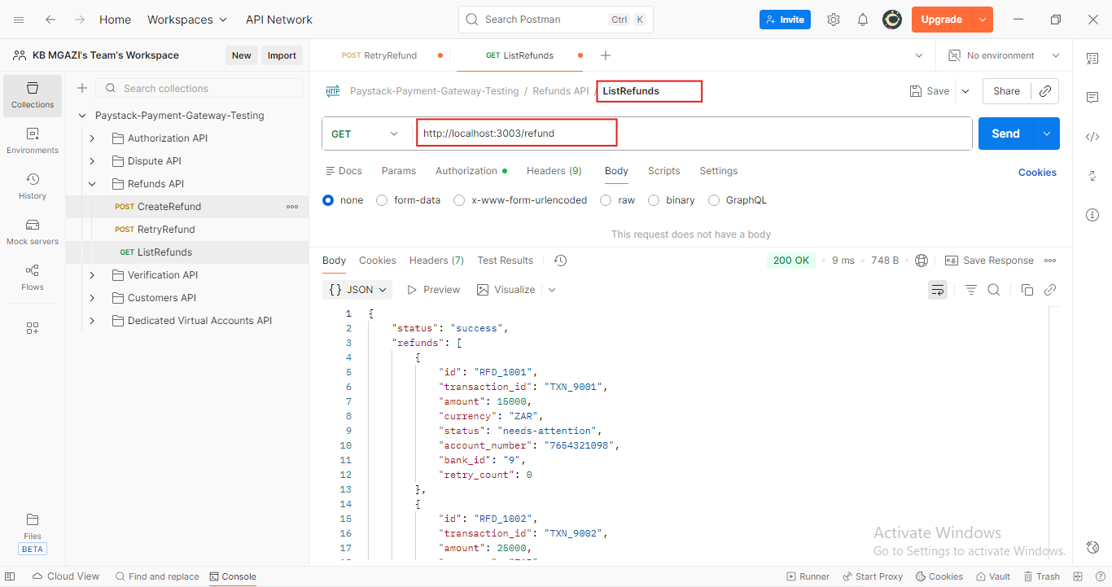
Response:
{
"status": "success",
"refunds": [
{
"id": "RFD_1001",
"transaction_id": "TXN_9001",
"amount": 15000,
"currency": "ZAR",
"status": "needs-attention",
"account_number": "7654321098",
"bank_id": "9",
"retry_count": 0
},
{
"id": "RFD_1002",
"transaction_id": "TXN_9002",
"amount": 25000,
"currency": "ZAR",
"status": "success",
"account_number": "8888888888",
"bank_id": "9",
"retry_count": 0
},
{
"id": "RFD_1003",
"transaction_id": "TXN_9003",
"amount": 18000,
"currency": "ZAR",
"status": "success",
"account_number": "1234567890",
"bank_id": "9",
"retry_count": 0
}
]
}

